Opportunity for two Asian Restaurants in Rome, Italy

Mauro Mucci

11th May 2021

# Introduction / Business Problem

## Background

Rome is a multinational European capital and it is one of the most visited cities in the world thanks to its priceless historical value.

In the city lives almost 3 million of people and tourism is always very active in any time of the year.

Thus, investing money in a restaurant could be a really good opportunity for the investors.

### Business Problem

Our client is looking into two different options:

* A luxury and high-level Japanese Restaurant
* An economic “all you can eat” Chinese Restaurant

Depending on the study results the client might invest in both restaurants.

Our target is to define two possible areas in Rome where opening the two restaurants could result in the most remunerate business possible.

# Data

## introduction

In order to answer the client’s request, the following data are analized:

* Municipi_Roma_15_wgs84_1.shp (shapefile)
* Municipi_di_Roma (Wikipedia Page)
* Benessere_economico_DATI2018.xlsx
* Foursquare API

## Data Description

The “***Municipi_Roma_15_wgs84_1.shp***” is a shapefile that contains the coordinates of the polygons for each Municipio of the city of Rome. A Municipio is a subdivision of the city territory that is done for administration purpose. For us it comes in handy so that we can grouped important data and characterise each area in order to find the most suitable for the restaurant.

Here is the plotting of the shapefile:

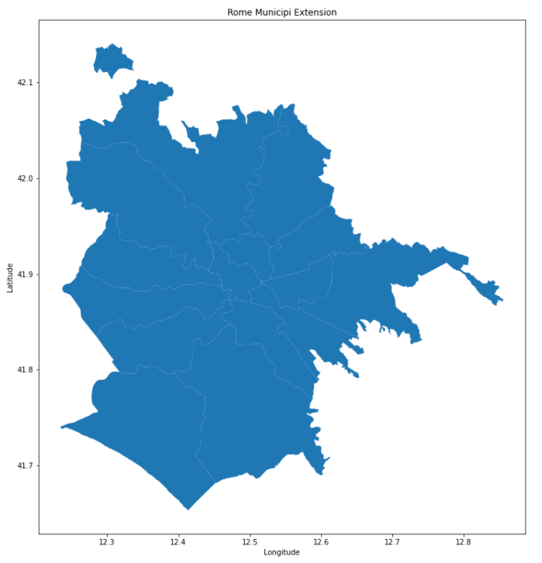

I will scrape the “***Municipi_di_Roma***” [wikipedia page](https://it.wikipedia.org/wiki/Municipi_di_Roma) in order to get important demographical data for each Municipio. The data are from 31st December 2018 and they describe the following: Population, Density and Area dimension.

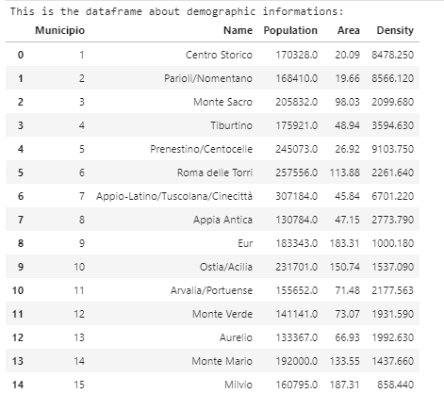

The “***Benessere_economico_DATI2018.xlsx***” excel file contains information about the average yearly salary of the population for each of the Municipio. The data are from the 31st December 2018. This file can be found in the following webpage: <https://www.comune.roma.it/web/it/roma-statistica-benessere-economico1.page>

Here is a screen dump of the excel table:

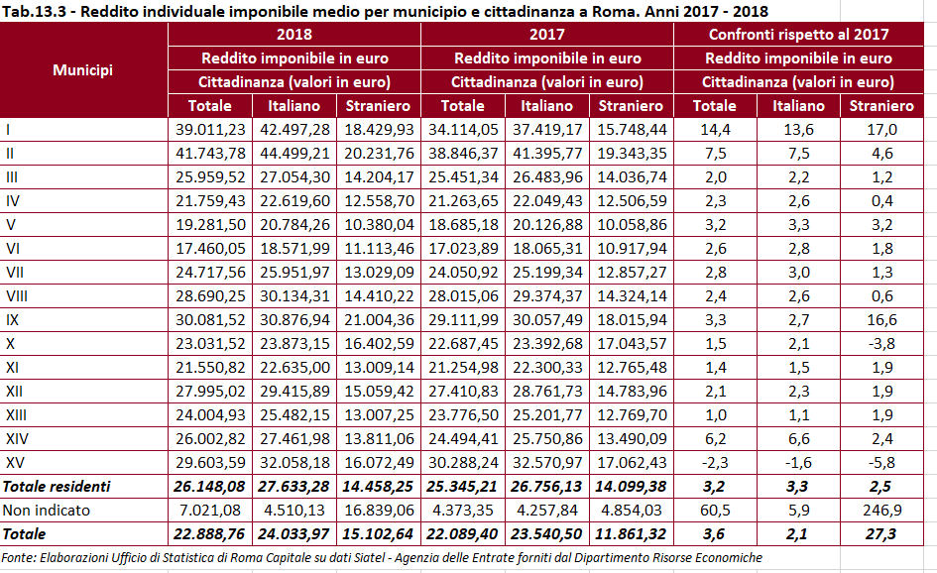

Foursquare API is a very useful service that can provide any sort of information about venues of a particular location. In our case we will obtain a Restaurants’ dataset that contains the following information: Restaurant Name, Position (latitude and longitude), CAP, Category/Type.

This is an example of the information retrieved by a Foursquare API request:

